Knowledge Sharing on Farm Water Loss

  - 27 August 2025

Project Summary:
CRDC, OneBasin CRC, and the University of Southern Queensland jointly funded a short-duration travel grant enabling Michael Scobie to attend the American Society of Agricultural and Biological Engineers (ASABE) annual conference in Toronto, Canada, in July 2025. This support partially covered airfare, accommodation, conference registration, and regional transportation. The funding aimed to facilitate international collaboration and knowledge exchange between Australian research teams and global leaders in agricultural engineering.
The ASABE conference is the largest annual gathering of agricultural and biological engineers worldwide. More than 2,000 delegates from academia, industry, and government agencies convened to share research breakthroughs, emerging technologies, and best-practice innovations. Sessions covered precision irrigation, climate-resilient crops, robotics for agronomic monitoring, and sustainable water-resource management. Michael engaged with keynote speakers and participated in targeted workshops on evaporation mitigation, directly aligning with his Australian cotton industry research.
Michael delivered a technical presentation titled “Mitigating Evaporation Loss from Water Storages: Ideas from the Australian Cotton Industry,” co-authored with Justine Baillie, Derek Long, Sarah Seton, Guangnan Chen, and Marti Beston. The presentation attracted significant interest, leading to follow-up discussions on joint experimental designs and shared funding opportunities across continents.

Outcomes & Impact for Industry:
The trip delivered valuable connections across North America’s leading cotton research hubs. Follow-up virtual workshops are scheduled for later this year to coordinate further collaboration and student exchanges. These collaborations will inform water-management strategies that enhance sustainability and productivity in cotton catchments across both hemispheres.

M&E Outcomes:
The trip delivered valuable connections across North America’s leading cotton research hubs. Collaborative proposals are now underway, including a joint grant application to test novel evaporation suppressants under US and Australian field conditions. Follow-up virtual workshops are scheduled for late August to coordinate trial logistics, data sharing, and student exchanges. These collaborations will inform water-management strategies that enhance sustainability and productivity in cotton catchments across both hemispheres.

People Connections:
In addition to the dozens of informal conversations with conference delegates, I had formal meetings with the following academics.

Name | Department | Organisation
John Reid | Director, Center for Digital Agriculture | University of Illinois Urbana-Champaign
Younsuk Dong | Assistant Professor, Department of Biosystems & Agricultural Engineering | Michigan State University
Alex Thomasson | Professor & Department Head, Department of Agricultural & Biological Engineering | Mississippi State University
Ajay Sharda | Department of Biological & Agricultural Engineering | Kansas State University
Madison P. Dixon | Agricultural Autonomy Institute | Mississippi State University
Daren Herran | Department of Biological & Agricultural Engineering | University of Nebraska–Lincoln
Christopher Neale | Daugherty Water for Food Global Institute | University of Nebraska–Lincoln
Davie Kadyampakeni | Soil, Water & Ecosystem Sciences Program | University of Florida
Dana Osborne Porter | Department of Biological & Agricultural Engineering | Texas A&M University
Burdette Barker | Department of Civil & Environmental Engineering | Utah State University
Derek M. Heeren | Department of Biological Systems Engineering | University of Nebraska–Lincoln
Patricia (Patti) Smith | Department of Biological & Agricultural Engineering | Texas A&M University
Janie Moore | Department of Biological & Agricultural Engineering | Texas A&M University
Andrew Olliver | Connected Services (Digital Product Manager, ISOBUS Services); Chairman, AEF | CNH Industrial / Agricultural Industry Electronics Foundation
Isaya Kisekka | Department of Biological & Agricultural Engineering | University of California, Davis

M&E Learnings:

Do you have recommendations for CRDC (eg RD&E gaps)?
Researchers and engineers across disciplines were highly receptive to collaboration, especially around student exchanges—allowing trainees to conduct trials during the US cotton season and then replicate those studies in Australia.

There’s strong appetite for joint projects in the southern US cotton belt, with no evident barriers to partnering or securing co-funding between Australian and American teams.

Coordinating summer research timelines presents a challenge, since many academics are employed on a nine-month contract tied to teaching semesters.
Australian cotton growers lead the world in innovative water-management practices. We've pioneered advanced irrigation scheduling, remote-sensing platforms, and precision-application technologies.
With the CRDC–OneBasin joint funded (Evaporative losses in the Northern Basin) being signed today, I will engage both long-standing and new collaborators in the USA to uncover novel evaporation-mitigation technologies. My outreach will include researchers, technology vendors, and field-trial coordinators who can accelerate solution identification.
I will focus on specialists in southern US cotton states—Mississippi and Texas—where extended growing seasons and high temperatures amplify evaporation challenges. I’ll also connect with teams in California, Utah, Nevada, and Arizona, regions where chronic water shortages are common.

Comment on project expenditure, noting any changes from the application budget.
The CRDC co-funded with OneBasin CRC and UniSQ to fund the travel - there were no variations to the expected shared budget

Appendix A

Photo gallery

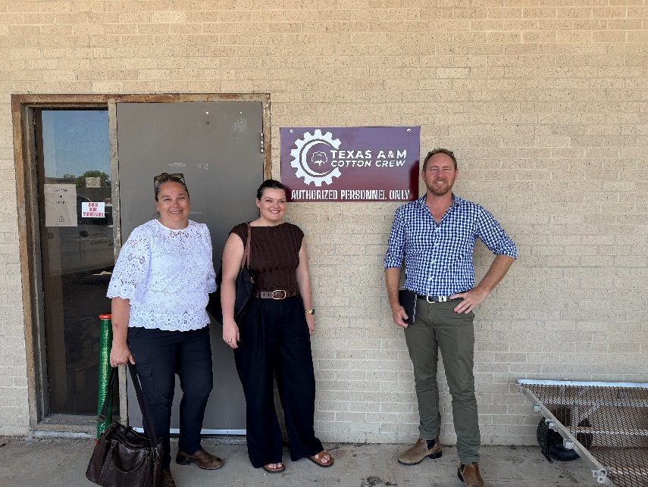
Figure 1: Justine Baillie, Marti Beeston and Michael Scobie at the Texas A&M Cotton Research Station, College Station, Texas
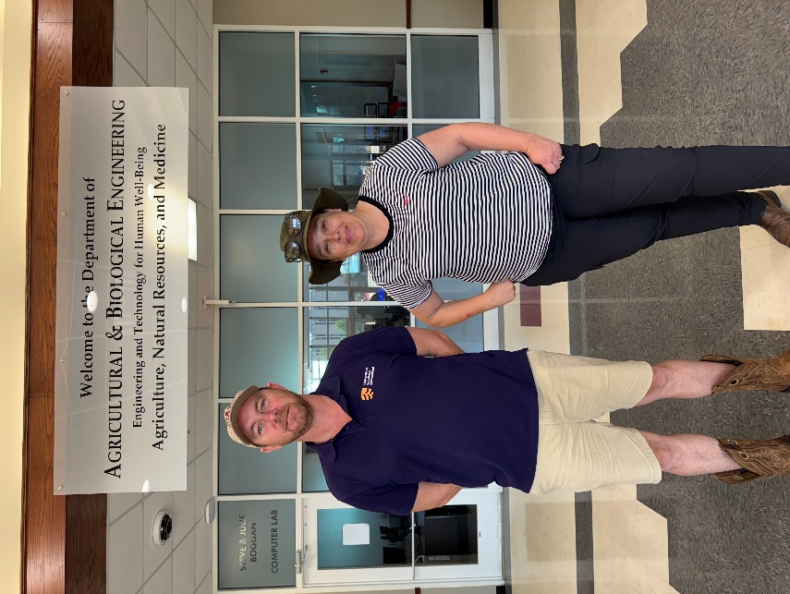
Figure 2: Michael Scobie and Justine Baillie at Mississippi State University Department of Agricultural and Biological Engineering, Starkville Mississippi
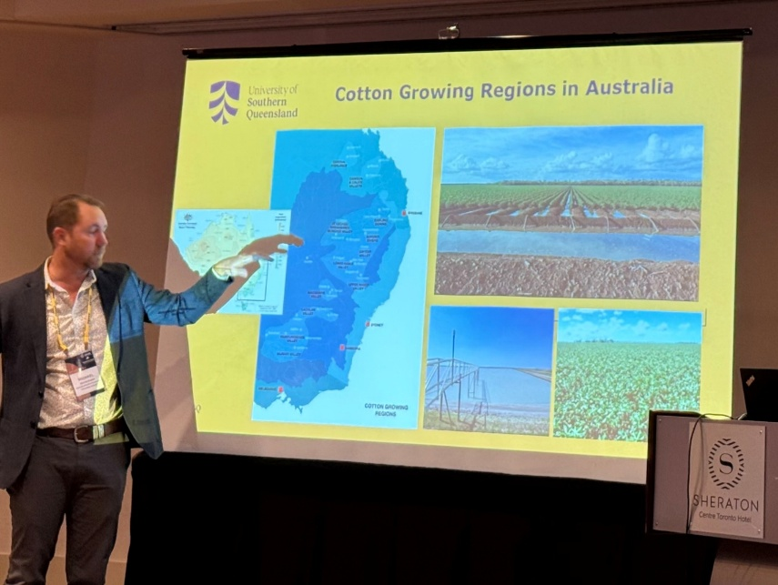
Figure 3: Michael Scobie presenting CRDC work at the American Society for Agricultural and Biological Engineers Conference in Toronto, Canada
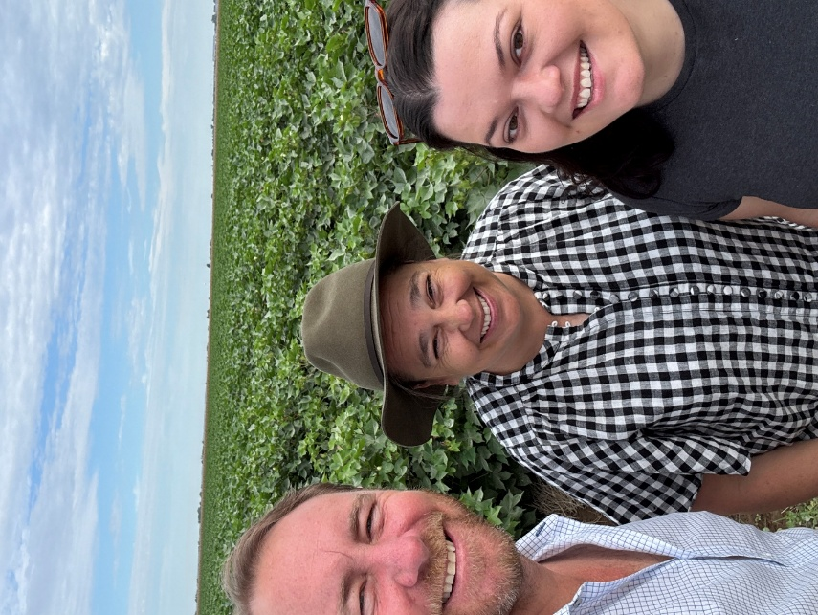
Figure 4: Michael Scobie, Justine Baillie and Marti Beeston in a cotton field in Mississippi
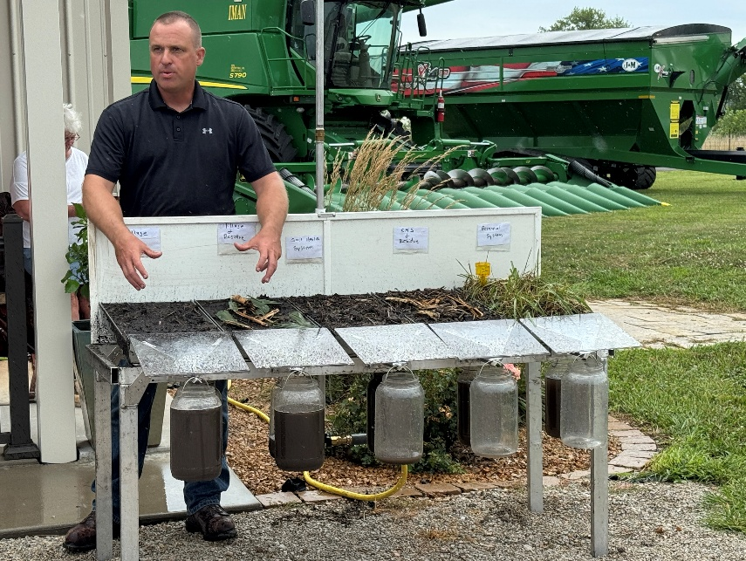
Figure 5: Engagement at Field day in Hillsboro, Indianna
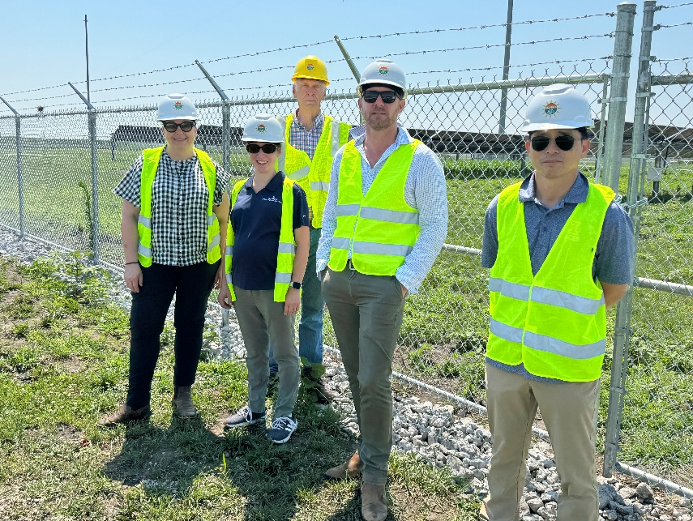
Figure 6: Touring the Center for Digital Agriculture Agrivoltaics research centre at the University of Illinois, Champain, Urbana, Ilinois
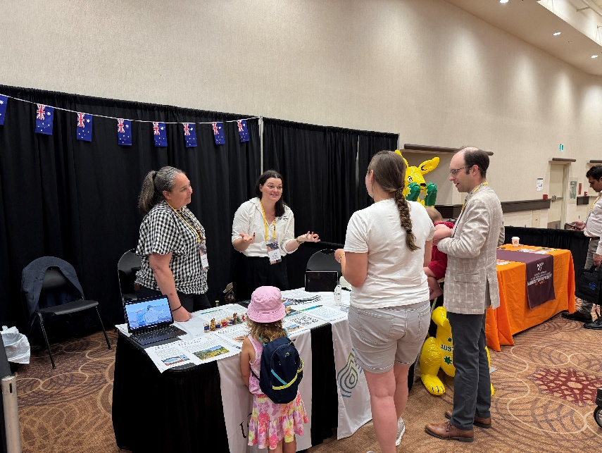
Figure 7: Justine Baillie and Marti Beeston at the ASABE Careers Fair, Toronto, Canada



unisq.edu.au
CRICOS: QLD 00244B, NSW 02225M | TEQSA: PRV12081

